# Project Hrun

Project Hrun will be an RPG with a fantasy theme, focusing on narrative, characters, and collectables, designed to appeal to younger children (8-12 years old)

It has also been decided that Project Hrun will be a browser-based game, and that it will be integrated into a larger website.

## The Prototype that you have been tasked with creating will implement the following minimum features:

A minimum of 2 interlinked areas.

Several characters, which will have the following behaviours.

Conversations, initiated by the player, which should change over the course of the game.

Relationship towards the player, which should change based on their interactions with the player.

Tasks, given to the player, which lead the player to interact with other characters and the environment. For example, to fetch an item from another character, or perform some action on an item in the world.

A set of collectables, collecting them should affect the behaviour of characters towards the player.

Simple graphics and icons that would appeal to the target audience.

A ‘point and click’ control system.

The game has to work on mobile!

## Website

The game has to have a website.

The website must include:

1. A landing page to introduce the game

2. A login page

3. Player forum to discuss the game, and report bugs

# Design of the game

## Concept

The general concept of the game is going to be a click to move fantasy RPG game that will include player interaction with several NPC’s and the exploration of different environments. This game is going to be targeted to a younger audience so there won’t be anything too overly complicated or graphic.

### Characters

Tyrone Treyshawn - Main Character

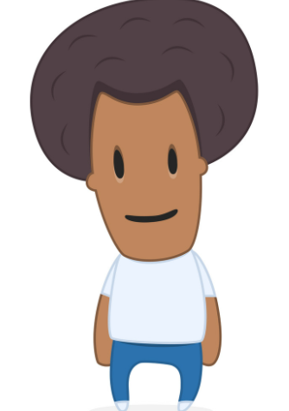

The Mystical Wizard of Joy – Quest Giver

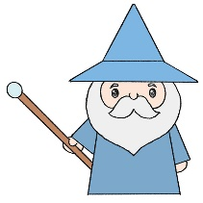

Greedy Gluttonous Goblin – Annoying NPC

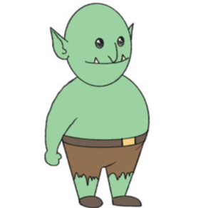

The Elk of Sorrow – Massive Elk

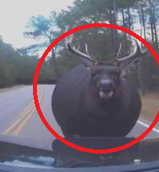

#### NPC Backstory

##### Tyrone Treyshawn –

Tyrone is a normal man who is living in the world of Aresmesha who is just trying to live a normal life. He is an eager young man who is lively and doesn’t get down easily.

###### The Mystical Wizard of Joy –

The Mystical Wizard of Joy is a joyous fellow who lives in the main town. He is a very generous and kind man who is willing to help others in times of need however recently he’s the one that needs help.

###### Greedy Gluttonous Goblin –

The Greedy Gluttonous Goblin is a horrible character, he adds NOTHING to the world. He usually talks about annoying things and is generally a terrible influence to all people. Stay away.

###### The Elk of Sorrow -

The Elk of sorrow is a sad being. Can someone help it? We don’t know. But it’s a passive character who isn’t interested in violence and just wants peace. Its sort of the game’s mascot.

### Interaction / Dialogue

The main Character (Tyrone Treyshawn) can interact with all the NPCs in the game. The Mystical Wizard of Joy is going to be the quest giver whose dialogue will be aimed at giving a player a quest. His dialogue will change If you complete his quest. The dialogue with the Goblin will be utterly meaningless and the main character will not be able to talk with the Elk of Sorrow because it’s an animal.

### Task / Quest

The Wizard gives you a quest to collect an item that is located in another part of the game. Once the item is retrieved the wizard will change dialogue and the player can keep the item. The Goblin and the elk cannot give the main character any quest.

### Map Design

The Map itself is going to consist of 3 areas. The main Area (Spawn) This will contain the Goblin and the Wizard NPC’S. The Forest, this will have the ELK NPC and an explorable forest environment and lastly the Dangerous Mines where the Player can find the quest item that the wizard gives you.

Main Spawn – Village with an explorable area outside of it. Nothing dangerous is here. The player can explore and walk around but no items can be found.

Forest – A large forest only area that is easy to get lost in. Who knows what’s out in the woods?

Dangerous Mines – Dangerous spooky area that will have a special item if found. That Item is part of the Wizards quest.

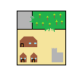

# Design of the website

For the design of the website, I was thinking that I could use a website template. I will then edit the template to fit the criteria of the task. The website will have 3 navigation options at the top, the Forum page, login / sign in page and the landing page to introduce the game to the players.

### Forum

For the Forum of the game, I am planning on creating a text box that the user can fill in to send to the developers of the game. The feedback will be emailed to the developers if the enter or send button is pressed.

### Login

The Login page will include a password and a re-enter password box as well as an email and confirm email box. These will also have validation to make sure any false info isn’t entered.

### Landing

The Landing page will have to contain the game. I’m hoping that I can import the completed GDevelop game into the landing page making it accessible and playable from there.